Q1) Write a program that inputs three integers from the keyboard and prints the sum, average and product.
Q2) Write a program that reads in the radius of a circle as an integer and prints the circle’s diameter, circumference and area. Use the constant value 3.14159 for π.
Q3) Using the techniques of this chapter, write a program that calculates the squares and cubes of the integers from 0 to 10. Use tabs to print the following neatly formatted table of values:
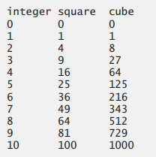
Q4) Write a program that asks the user to enter the total time elapsed, in seconds, since an event and converts the time to hours, minutes and seconds. The time should be displayed as hours:minutes:seconds. [Hint: Use the remainder operator].
Q5) Write a program to calculate arithmetic, geometric, and harmonic mean.

